**Quiz 1C Take Home NAME_____Ryan Tolentino_______**

**CSC 130 Fall 2016**

**Learn about flowchart from various sources e.g.** <https://www.youtube.com/watch?v=hN9xemJYwos>

**then consider different programs below, convert them into flowcharts, answer all questions and complete the tracing table:**

1. **Consider the program below (all items independent processing) :**

listA = [1,2,1,1]

for item in listA:

print( item*2 )

Convert it to a flowchart:

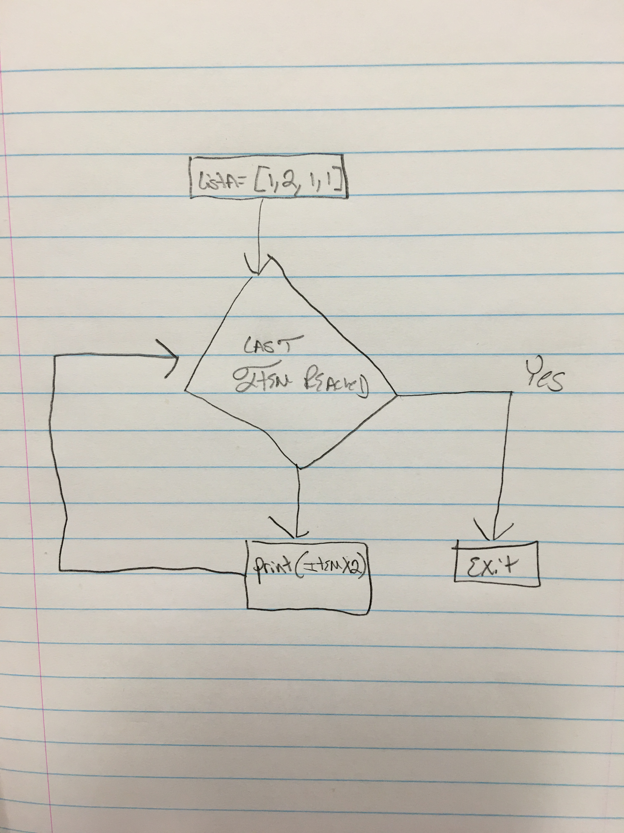

What will be result of execution of each cycle of the **for** loop for the above program? Complete the Trace table.

|  |  |
| --- | --- |
| Cycle | Item |
| Before the **for** loop | -[1,2,1,1] |
| After Cycle 0 | 2 |
| After Cycle 1 | 4 |
| After Cycle 2 | 2 |
| After Cycle 3 | 2 |

What will be the output of the above program?

__2___________________________

___4_________________________

_____2________________________

_____2________________________

1. **Consider the program below (selected items independent processing):**

listA = [1,2,1,1]

for item in listA:

if item == 1:

print( item+3)

Convert it to a flowchart:

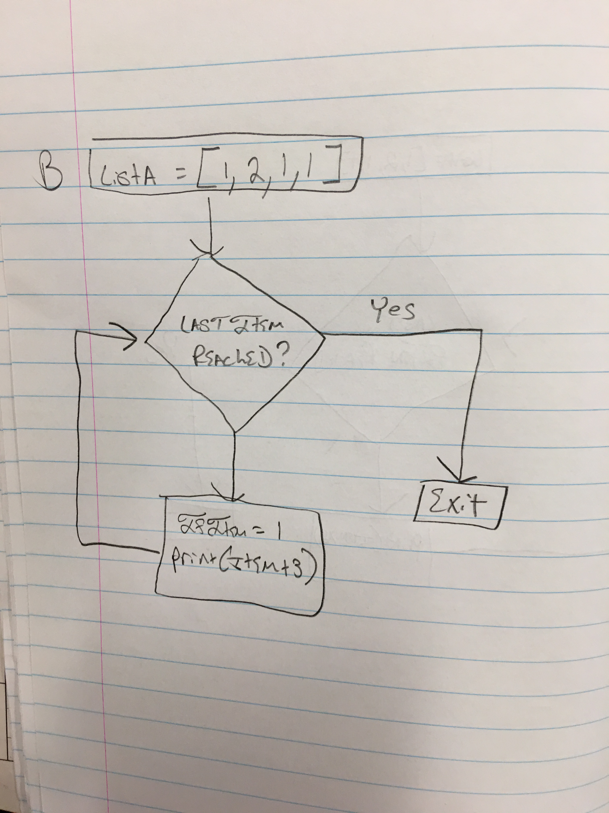

What will be result of execution of each cycle of the **for** loop for the above program? Complete the Trace table.

|  |  |
| --- | --- |
| Cycle | Item |
| Before the **for** loop | -[1,2,1,1] |
| After Cycle 0 | --[1,2,1,1] |
| After Cycle 1 | 4 |
| After Cycle 2 | 4 |
| After Cycle 3 | 4 |

What will be the output of the above program?

________4_____________________

________4_____________________

_________4___________________

1. **Consider the program below (all items counting):**

listA = [1,2,1,1]

count=0

for item in listA:

count=count+1

print(count)

print(count)

**Convert it to a flowchart:**

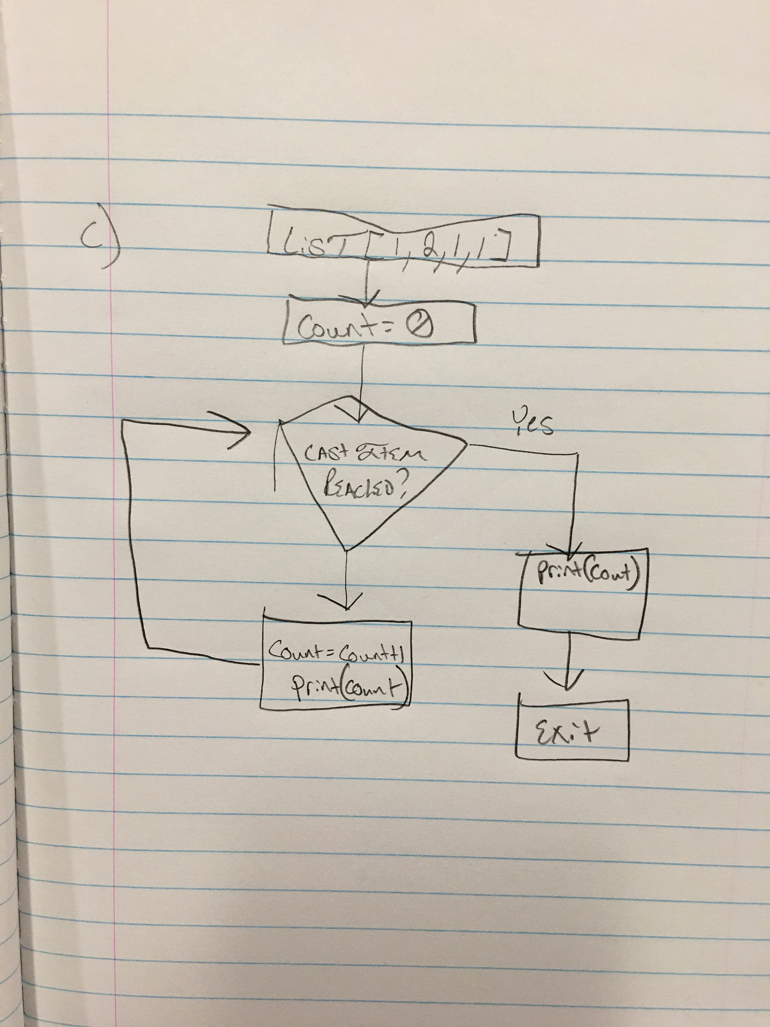

What will be result of execution of each cycle of the **for** loop for the above program? Complete the Trace table.

|  |  |  |
| --- | --- | --- |
| Cycle | item | count |
| Before the **for** loop | - [1,2,1,1] | 0 |
| After Cycle 0 | 1 | 1 |
| After Cycle 1 | 2 | 2 |
| After Cycle 2 | 1 | 3 |
| After Cycle 3 | 1 | 4 |
| After the **for** loop | -[ ] | 4 |

What will be the output of the above program?

_______________1______________

_______________2______________

________________3_____________

_______________4______________

______________4_______________

1. **Consider the program below (selected items counting):**

listA = [1,2,1,1]

count=0

for item in listA:

if item == 1:

count=count+1

print(count)

**Convert it to a flowchart:**

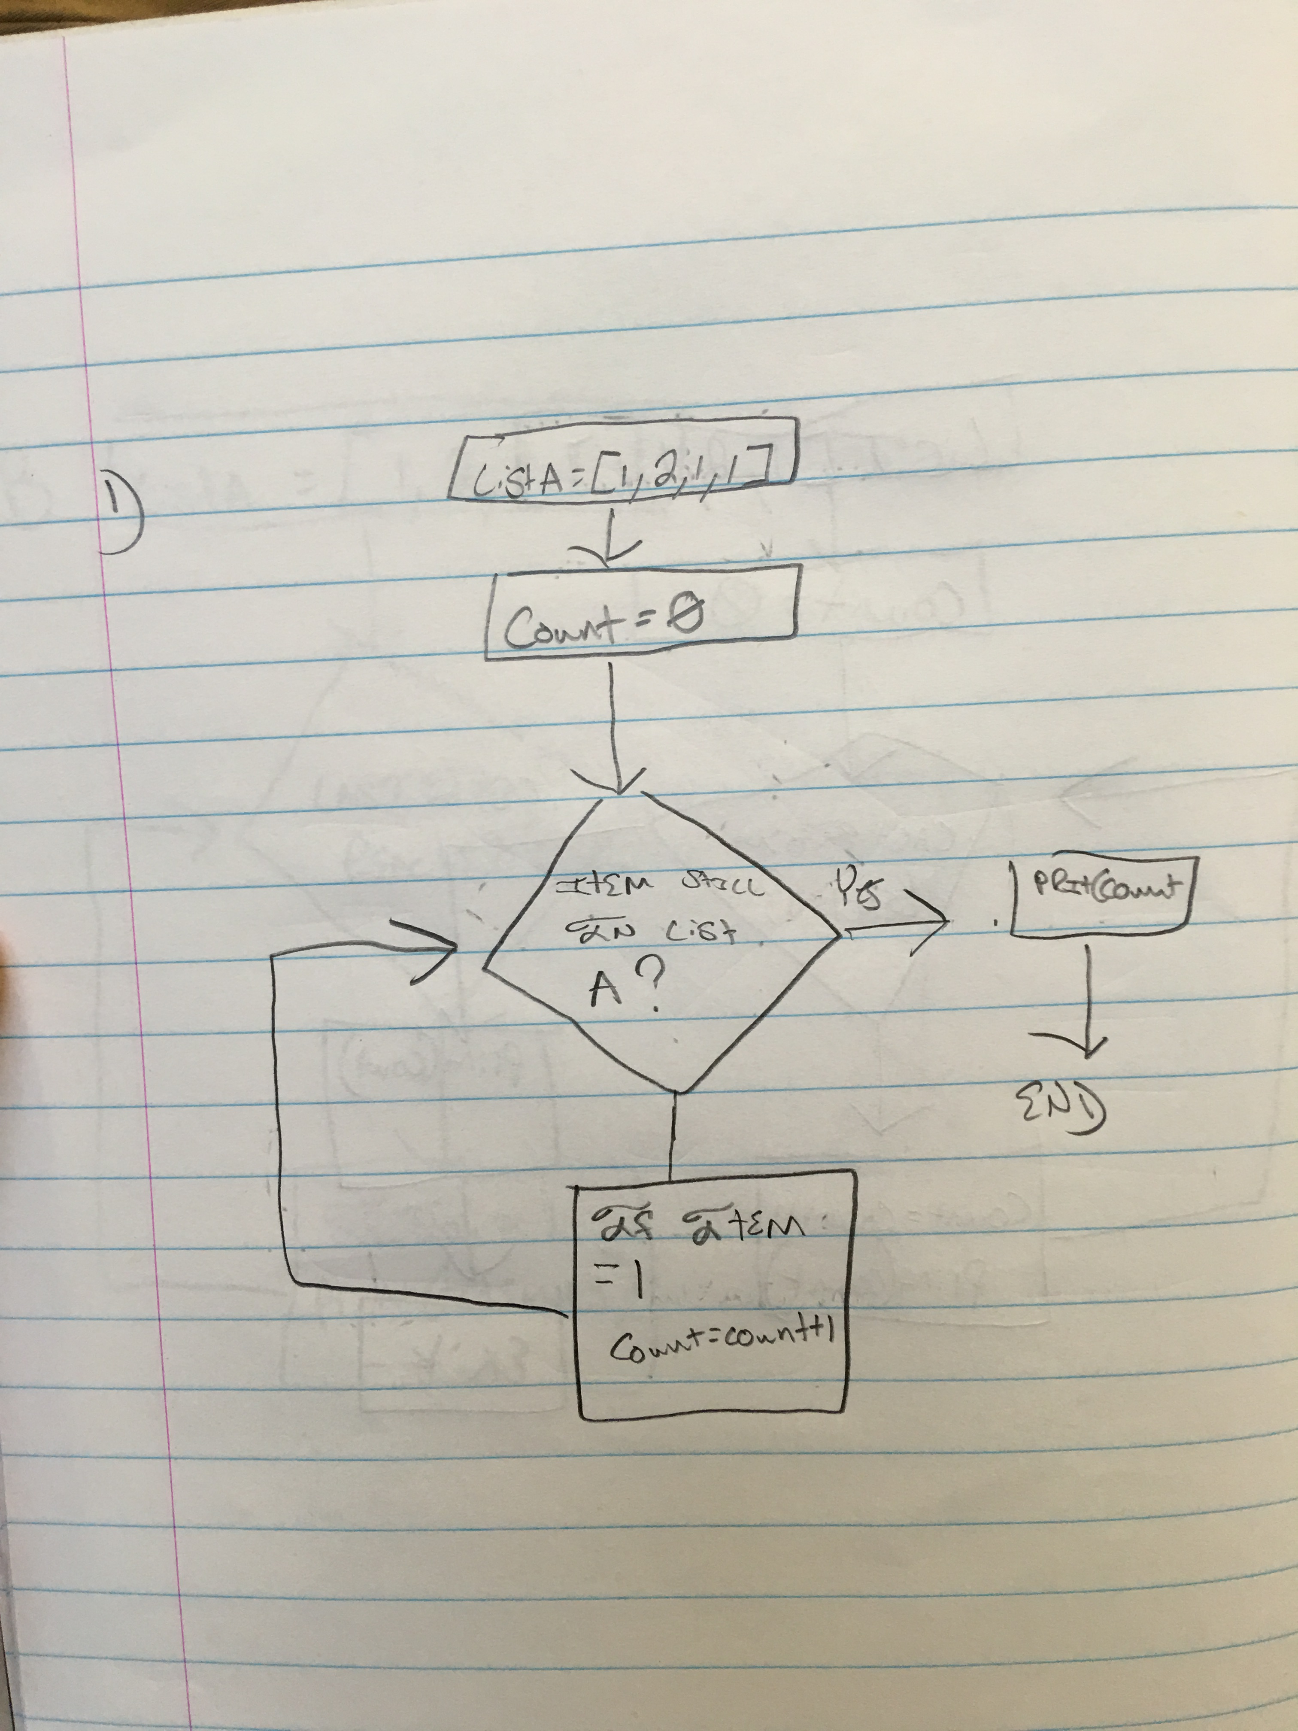

What will be result of execution of each cycle of the **for** loop for the above program? Complete the Trace table.

|  |  |  |
| --- | --- | --- |
| Cycle | item | count |
| Before the **for** loop | - [1,2,1,1] | 0 |
| After Cycle 0 | 1 | 1 |
| After Cycle 1 | 2 | 1 |
| After Cycle 2 | 1 | 2 |
| After Cycle 3 | 1 | 3 |
| After the **for** loop | - [ ] | 3 |

What will be the output of the above program?

_____________3_______________

1. **Consider the program below (all items aggregation):**

listA = [1,2,1,1]

sum=0

for item in listA:

sum=sum + item

print(sum)

**Convert it to a flowchart**

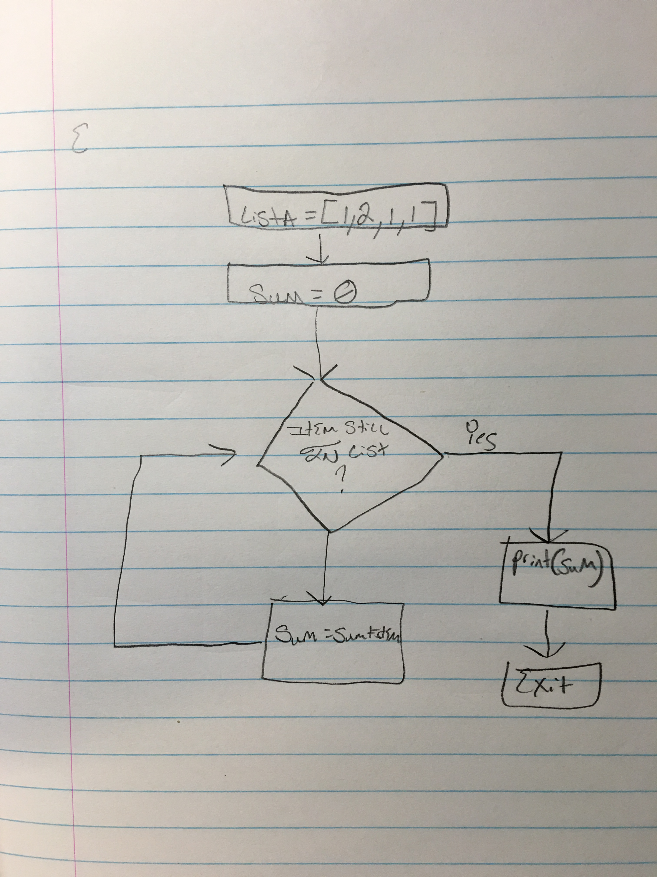

What will be result of execution of each cycle of the **for** loop for the above program? Complete the Trace table.

|  |  |  |
| --- | --- | --- |
| Cycle | item | sum |
| Before the **for** loop | -[1,2,1,1] | 0 |
| After Cycle 0 | 1 | 1 |
| After Cycle 1 | 2 | 3 |
| After Cycle 2 | 1 | 4 |
| After Cycle 3 | 1 | 5 |
| After the **for** loop | -[] | 5 |

What will be the output of the above program?

___________5__________________

1. **Consider the program below (Selected Items Aggregation):**

listA = [1,2,1,1]

sum=0

for item in listA:

if item == 1:

sum=sum + item

print(sum)

**Convert it to a flowchart:**

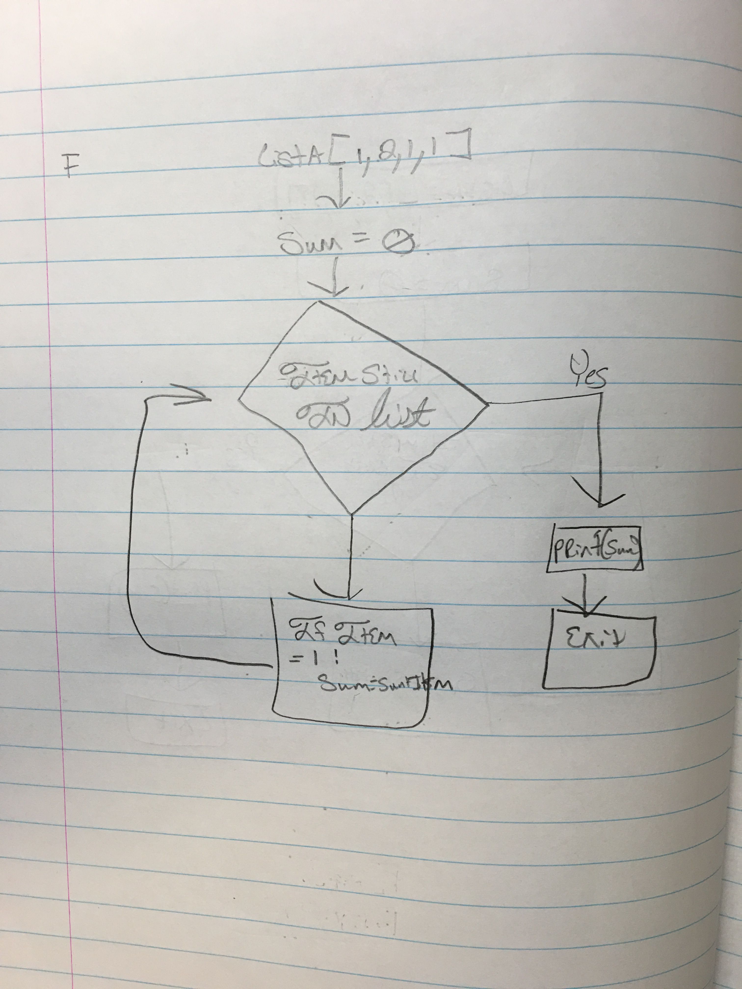

What will be result of execution of each cycle of the **for** loop for the above program? Complete the Trace table.

|  |  |  |
| --- | --- | --- |
| Cycle | item | sum |
| Before the **for** loop | -[1,2,1,1] | 0 |
| After Cycle 0 | 1 | 1 |
| After Cycle 1 | 2 | 1 |
| After Cycle 2 | 1 | 2 |
| After Cycle 3 | 1 | 3 |
| After the **for** loop | -[] | 3 |

What will be the output of the above program?

___________3__________________

1. **Consider the program below (Current & Next Item + Independent Processing)**

listA = [1,2,1,1]

for index in range(len(listA)-1):

print( listA[index], listA[index+1] )

**Convert it to a flowchart:**

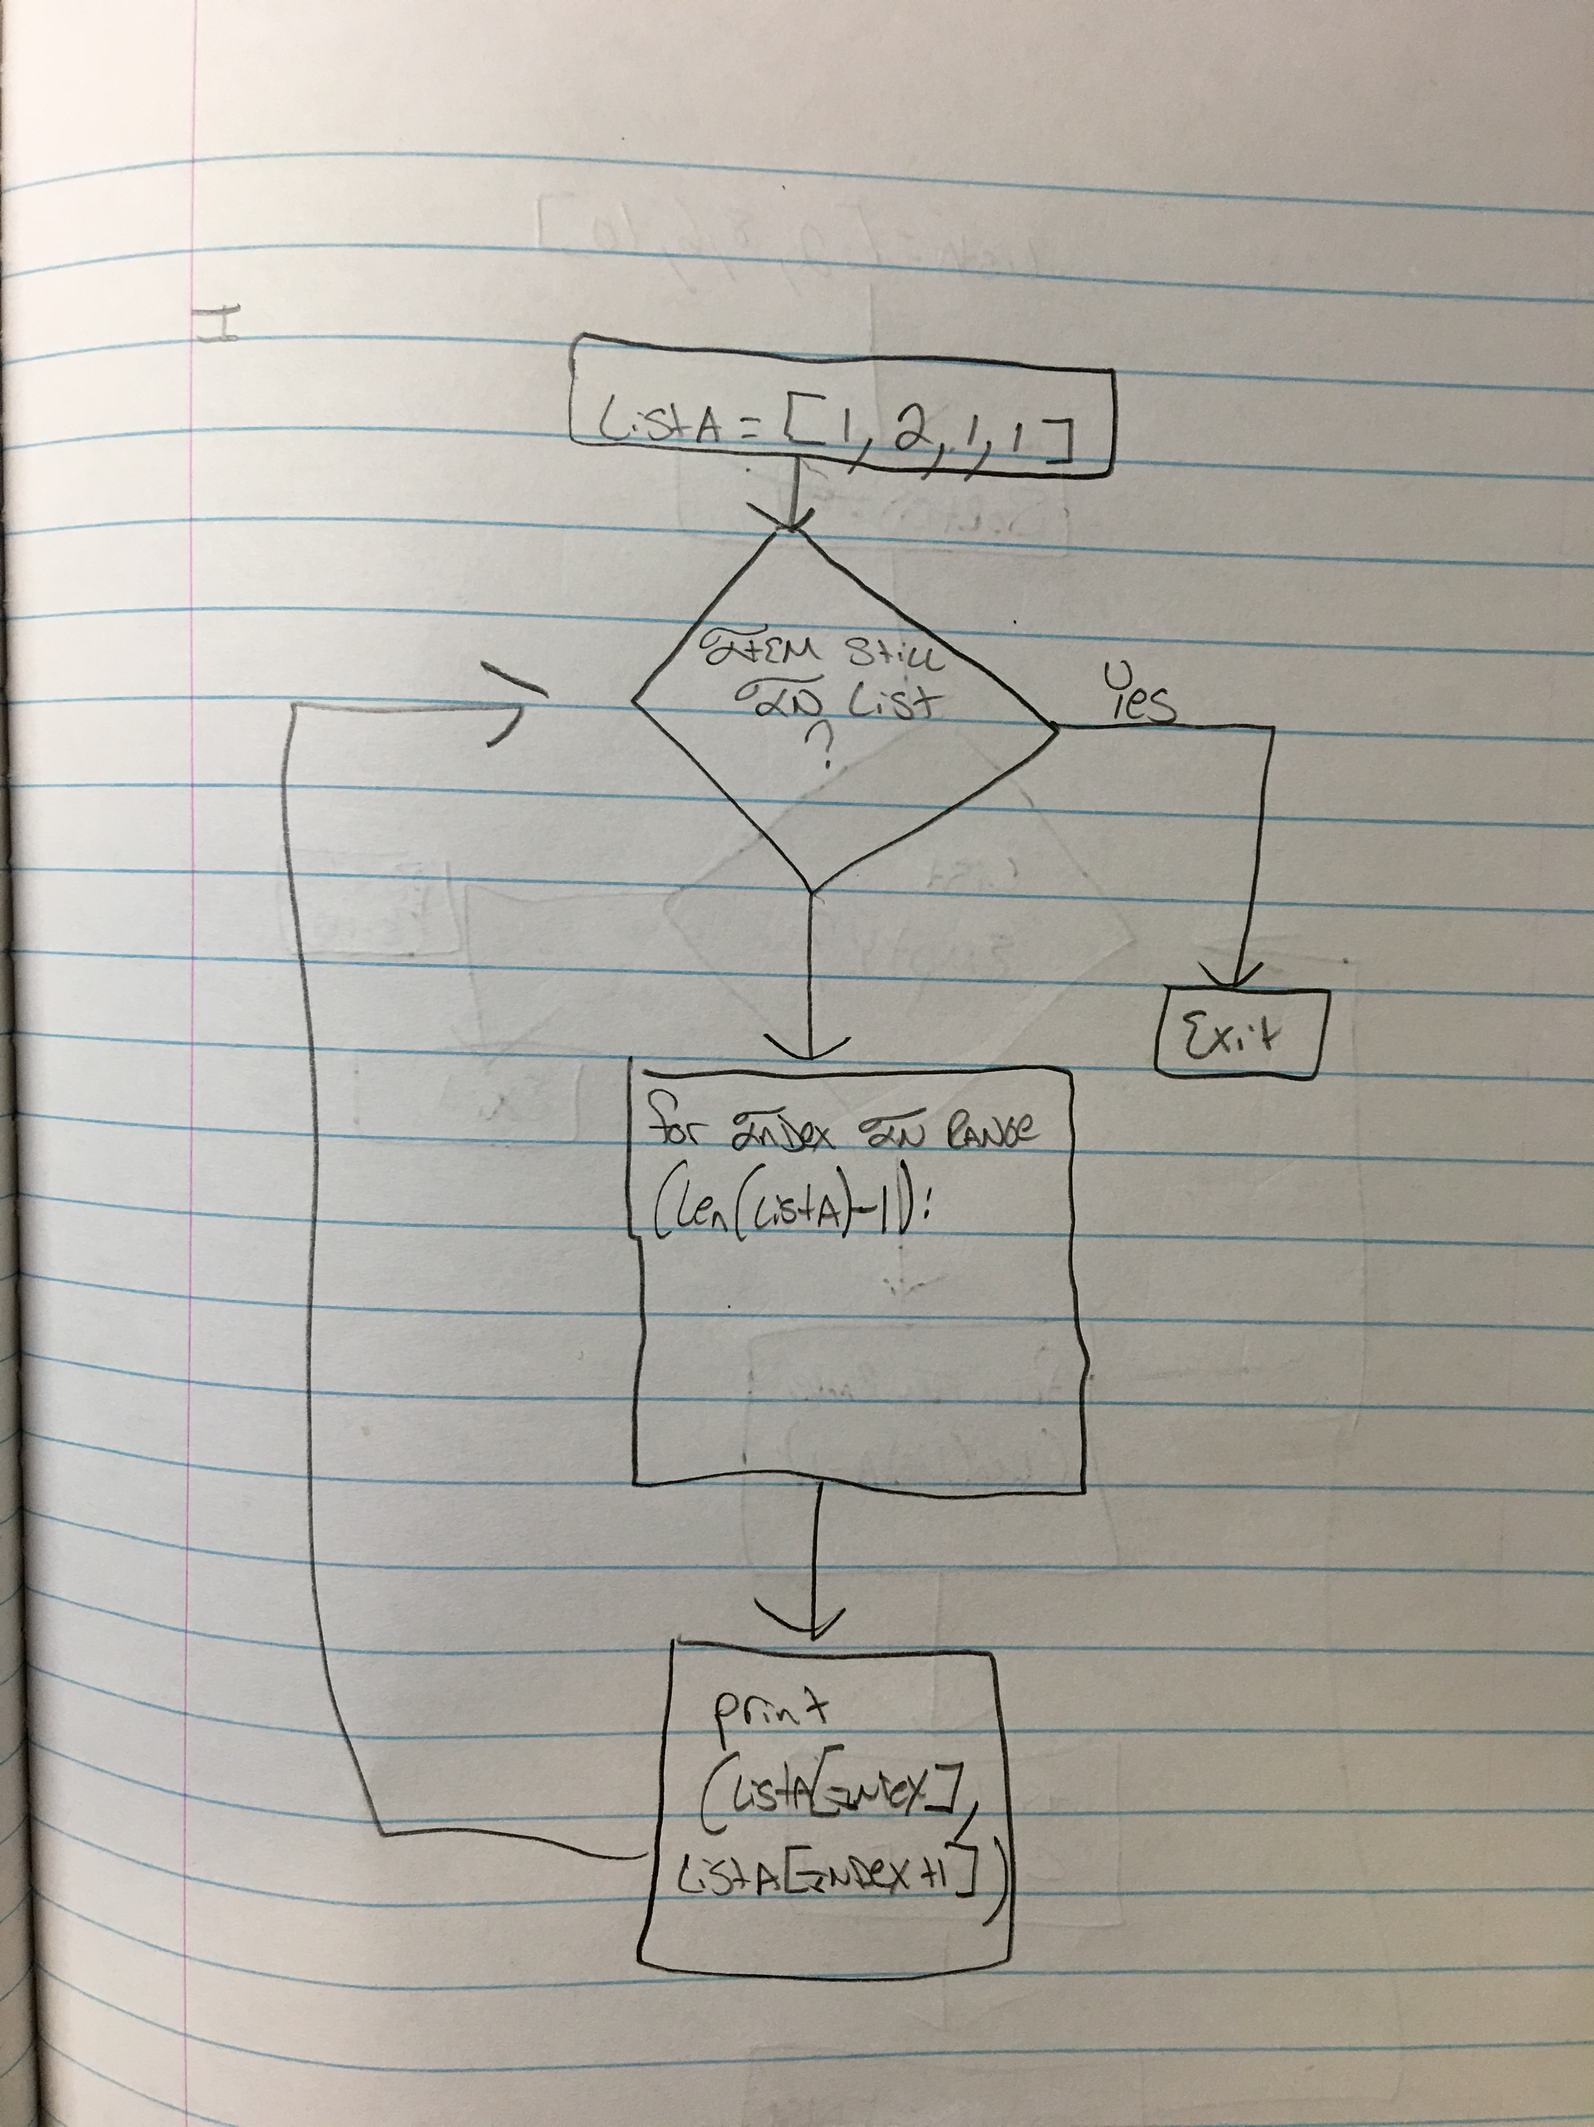

What will be result of execution of each cycle of the **for** loop for the above program? Complete the Trace table.

|  |  |
| --- | --- |
| Cycle | listA[index] listA[index+1] |
| Before the **for** loop | - [1,2,1,1] -[1,2,1,1] |
| After Cycle 0 | 1 2 |
| After Cycle 1 | 2 3 |
| After Cycle 2 | 1 2 |
| After the **for** loop | - 1 - |

What will be the output of the above program?

_____ (1, 2)_____

____ (2, 1)______

____ (1, 1)______

1. **Consider the program below (Selected Current & Next Item + Aggregation)**

listA = [2, 8, 6, 10]

sorted = True

for i in range(len(listA)-1):

if listA[i] > listA [i+1]:

sorted = False

print (sorted)

**Convert it to a flowchart:**

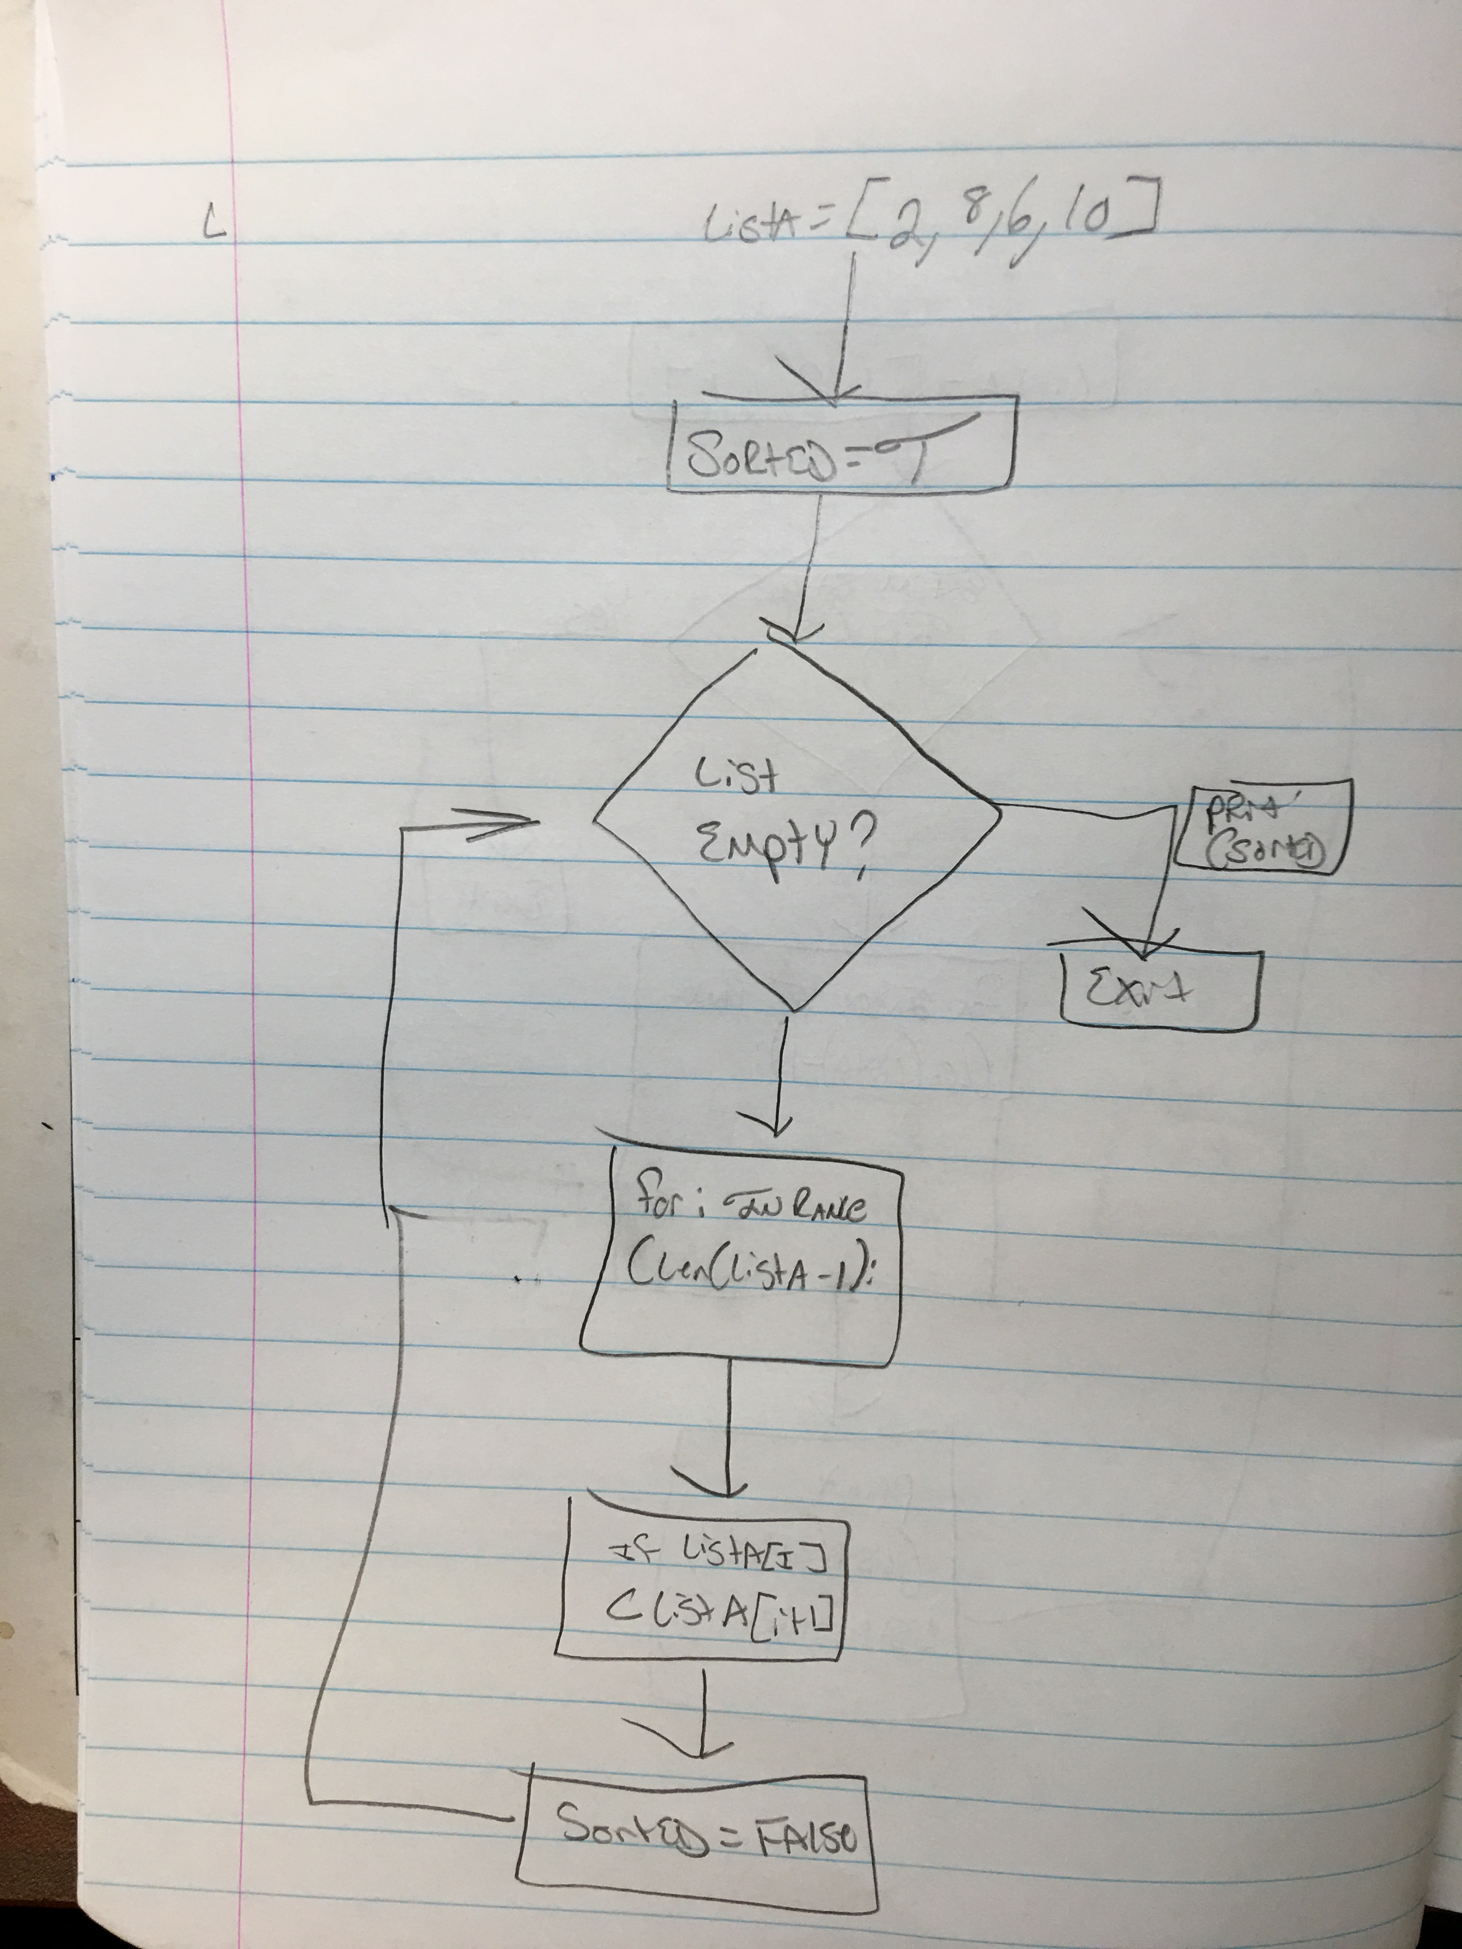

What will be result of execution of each cycle of the **for** loop for the above program? Complete the Trace table.

|  |  |  |
| --- | --- | --- |
| Cycle | listA[index] listA[index+1] | sorted |
| Before the **for** loop | - [2,8,6,10] -[ |  |
| After Cycle 0 | 2 3 | FALSE |
| After Cycle 1 | 8 9 | FALSE |
| After Cycle 2 | 6 7 | FALSE |
| After the **for** loop | - 10 - |  |

What will be the output of the above program?

_False_________